Robotic Hand



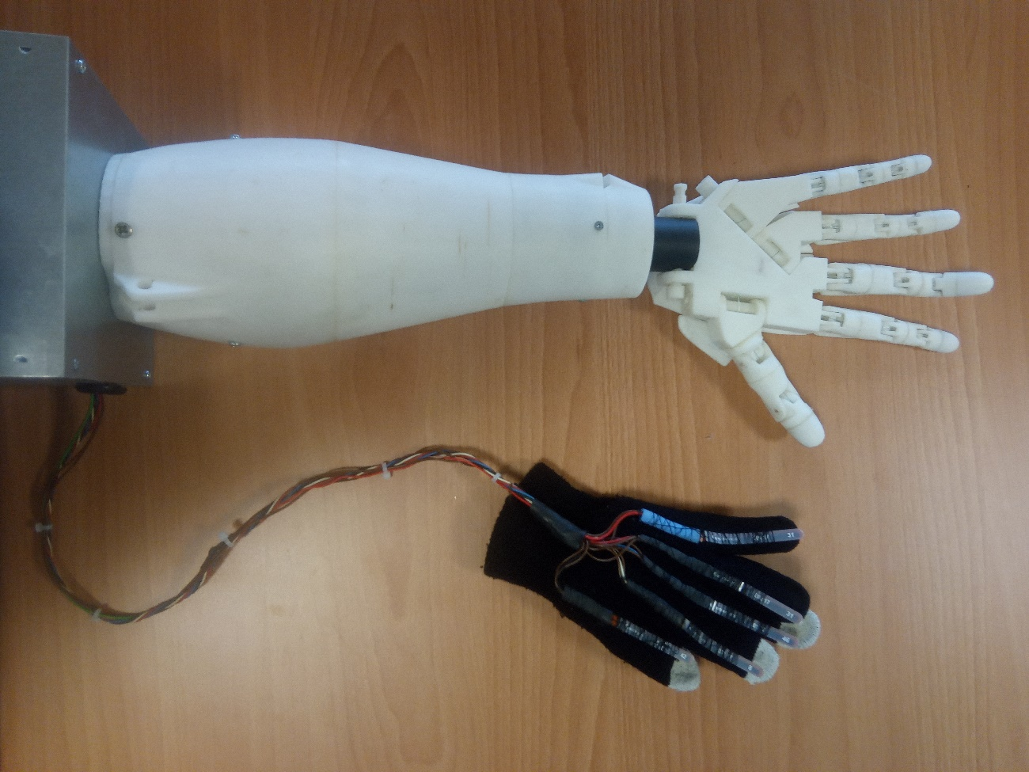

# Description

Robotic hand made of 3d printed plastic. It copies the finger moves made with the glove and can play rock, paper, scissors with it. Project made in RLP (Robotics Language and Planning) of 2016 - 2017. It was made having in mind a demo of a robotic hand controlled by your own hand.

The 3D printed hand model used was the one made by “InMoov”. In their web side you can find all the human body parts to print in 3D. <http://inmoov.fr/>

# Instructions

To switch on the hand, plug the electricity C13 cable into the box switch. The switch must be lighted in order to work.

Put the globe in your right hand (be careful with the flex sensors, it’s recommended to use a plastic glove cobbering the cotton glove to improve the sensibility of the sensors).

Once the glove is correctly in your hand, open and close your fingers and the hand should do the same. In addition to the imitation the hand can play different modes of the “rock, paper, scissors” game. This are all the modes of the robotic hand:

## Imitation Mode:

The hand imitates all the moves of the glove. It’s the default mode of the hand, it’ll always come back to this mode.

## Paper, Rock, Scissors Random Mode:

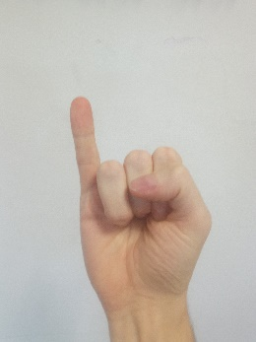The playing mode of the hand, the move of the hand will be random. And if it wins, losses or it’s a draw it’ll make a different position of ending before to come back to the previous mode.

To run this mode, keep all the fingers closed except for the little, that has to be stretched, keep that position for a few seconds.

## Paper, Rock, Scissors Win Mode:

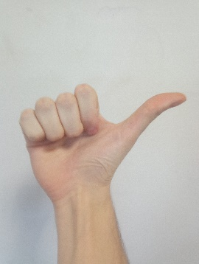On this mode the hand will always win. It doesn’t have any position at the end and it’ll come back to default mode.

To run this mode, keep all the fingers closed except for the thumb, that has to be stretched, keep that position for a few seconds.

## Paper, Rock, Scissors Lose Mode:

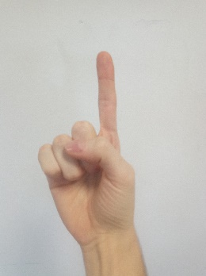On this mode the hand will always lose. It doesn’t have any position at the end and it’ll come back to default mode.

To run this mode, keep all the fingers closed except for the index, that has to be stretched, keep that position for a few seconds.

# Technical Section

## Known Issues

The flex sensors are really sensitive sensors and they use to lose calibration over time, this may cause the hand not to work properly, having difficulty detecting some special modes or even not moving correctly some finger.

If some finger gets detached it just need to be attached with thermal silicon, but be careful not to fill the inside of the finger if you do it, the string inside must move freely inside.

If a servo brakes, it can be replaced easily just unplug the plastic wheel of that servo that pull the strings and replace the servo, before to put again the wheel in the new servo, make sure that the wheel it’s in the correct position to not brake the strings.

If a string brakes, the hole hand and finger must be disassembled in order to replace it.

## Calibration

In order to calibrate the hand again you will have to remove carefully the upper part of the box that have the plastic hand attached to it and connect the Arduino to the computer in order to manipulate the code.

At the end of the code there are the calibration variables of the flex sensors for the hand to recognise the positions. They are separated in Max and Min positions.

## Code Details

The code is structured as a state machine, it has a default state, 3 game states and transition states between that states states. At the end of the code there are variables to control the jump between variables.

Inputs and Outputs of the hand follow the next sequence:

Thumb -> Black cable is connected to Analogic 1 of the Arduino and it triggers the servo in the output 4

Index -> White cable is connected to Analogic 2 of the Arduino and it triggers the servo in the output 5

Middle -> White cable is connected to Analogic 4 of the Arduino and it triggers the servo in the output 6

Ring -> White cable is connected to Analogic 3 of the Arduino and it triggers the servo in the output 7

Little -> White cable is connected to Analogic 5 of the Arduino and it triggers the servo in the output 8

## Possible Next Steps

One necessary improve of the robotic hand is the system that detect the movements of the human hand. The flex sensors aren’t a durable solution, one way to improve it is to remake this glove with a system of strings and potentiometers to detect when the fingers are closing or opening.

As a project made to be improved and added to other projects as an application, it can be improved adding a way to send it positions by Wi-Fi, Bluetooth or some other way in order to make the communication with it easy and portable to other projects.